December at Greenbank Farm

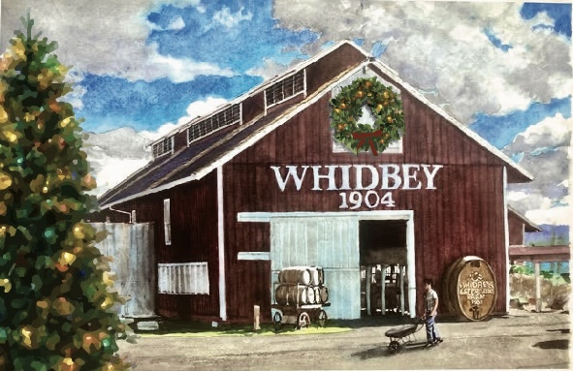

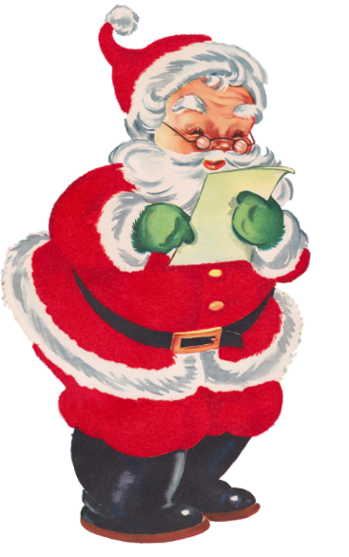
Holiday Markets
Sat & Sun-- December 9th - 10th & 16th - 17th
^{10am – 4pm}
Farm Holiday Lights
Daily through December

Santa’s Workshop
Holiday Crafts & Clementine Face Painting
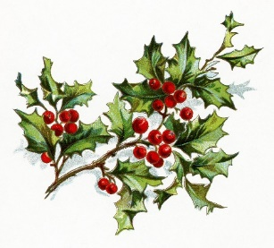
Sat & Sun -- December 9 th–10 th & 16th–17th
Santa: 10:30 am-12:30 pm and 1:30-3:30 pm

Carolers & Live Music
Coupeville Glee Club December 9th 10am-noon
Harp Music by Rain December 17th 11am-1pm

