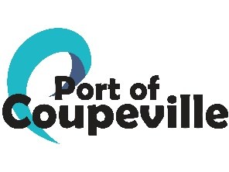
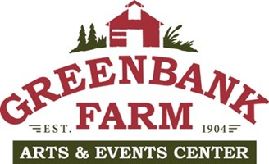 Barn A Bids
February 28, 2025
COMPANY | EMAIL | BID AMOUNT
Creative Roof Solutions | Robert@creativeroofsllc.com | $154,660.00
Amer-X Roofing | amerxroofing@msn.com | $242,000.00
Olympic Roofing | jen@olympicroofingllc.com | $165,000.00
Signature Roofing | signatureroofservices@gmail.com | $175,000.00
Woodridge Construction | woodridgeconstructionllc@gmail.com | $221,170.00
Apex Roofing | Office@apex-roofing.com | $244,950.00
Alpine Roof & Construction/Arrowhead Roof Cleaning | brettwiddincombe@gmail.com | $225,000.00
Alpha Developers | sales@alphadevelopersllc.com | $190,000.00

