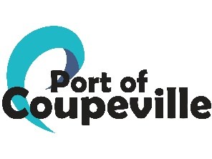
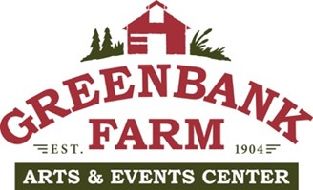 Barn B Bids
February 28, 2025
COMPANY | EMAIL | BID AMOUNT
Creative Roof Solutions | Robert@creativeroofsllc.com | $85,690.00
Signature Roofing | signatureroofservice@gmail.com | $97,500.00
Olympic Roofing | jen@olympicroofingllc.com | $100,000.00
AmerX Roofing | amerxroofing@msn.com | $126,500.00
Woodridge Construction | Woodridgeconstructionllc@gmail.com | $154,620.00
Apex Roofing | office@apex-roofing.com | $143,975
Alpine Roof Cleaning & Construction/Arrowhead Roof cleaning LLC | brettwiddicombe@gmail.com | $170,000
Alpha Developers | sales@alphadevelopersllc.com | $100,000

