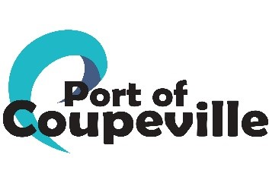
Request for Proposals

Replace Roof on Historic Greenbank Barn at the Greenbank Farm

Barn B
Bids Due: Wednesday, February 19, 2025 3 pm
Email: projectmanager@portofcoupeville.org
In person: 765 Wonn Rd, Suite E, Jim Davis House, Greenbank Farm, Greenbank
Pre-bid Walk Through: Tuesday January 28, 2025, 11:30 am
765 Wonn Rd, Greenbank, WA
Budget: $ 170,000
Proposed Time of Work: March- April 2025
Contact: Mary Hogan; Project Manager 360 222 3051 projectmanager@portofcoupeville.org

About the Property
The Greenbank Farm Barn B holds a Cheese Shop and commercial kitchen on the first floor and storage on the second floor.
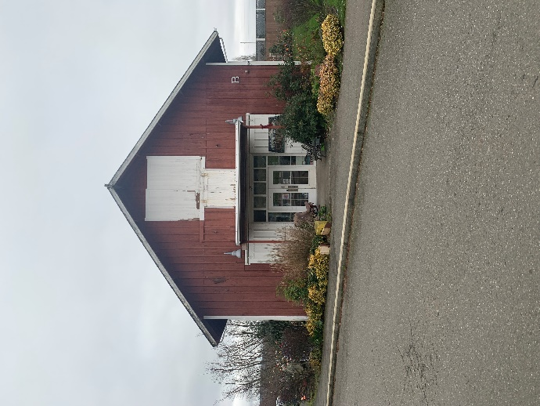

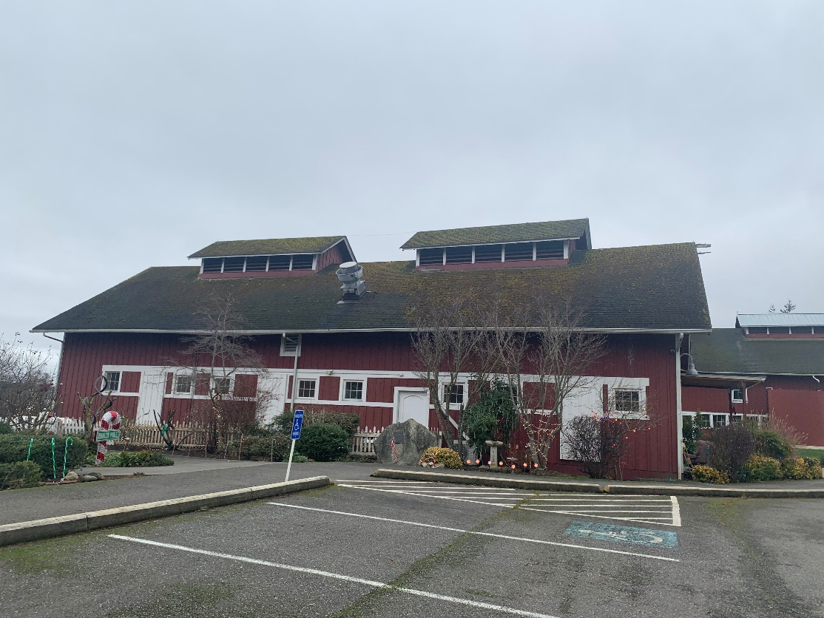
North Side of Barn B

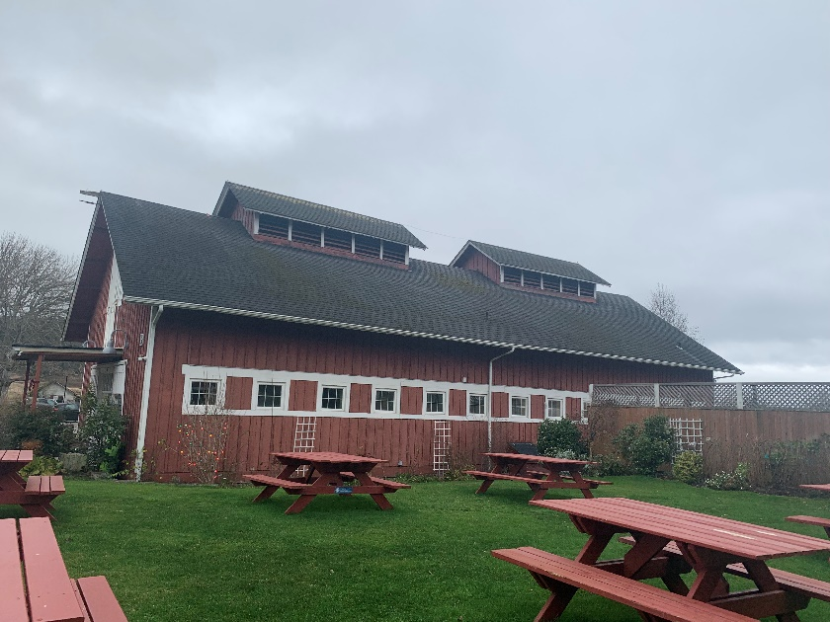
South Side of Barn B
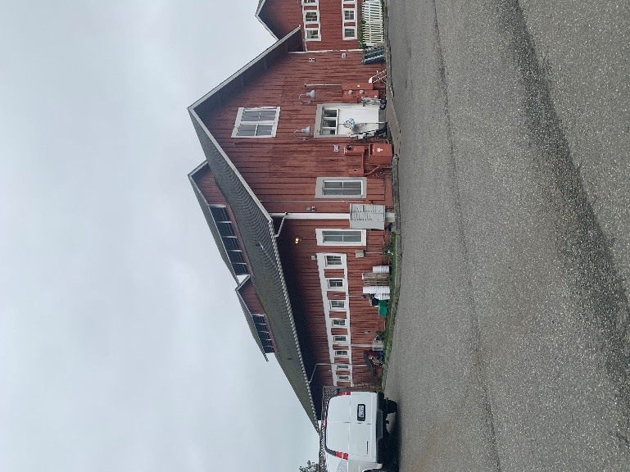
Back of South Side of Barn B
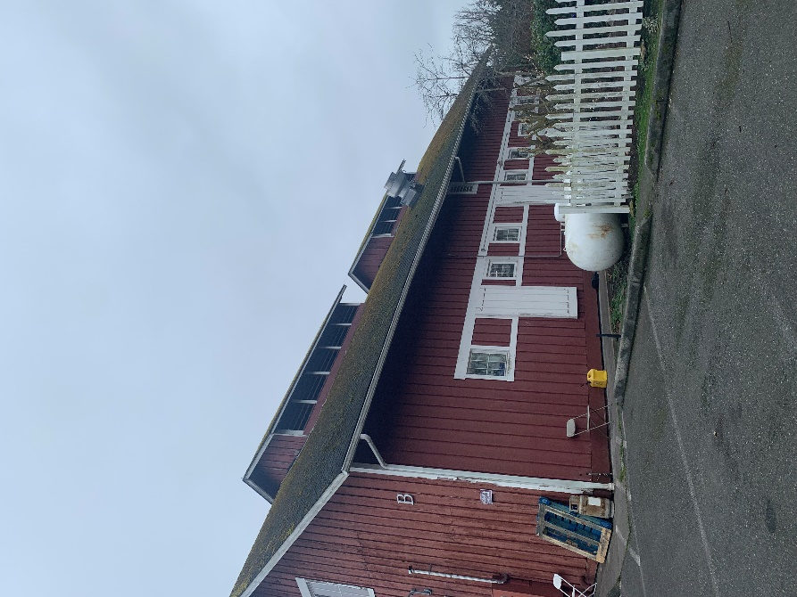
North Side from back

Roof Dimensions: 90’ x 25’ (each side)
Cupolas: Each face is 24’ x 8’

The Project
Barn B holds a cheese shop and commercial kitchen on the first floor and storage on the second floor. The cupolas are to be covered in silver metal to match Barn A, the rest of the barn will be done in Certain Teed’s Landmark TL (Triple Laminate) composition shingles to match Barn A.

Permits will be acquired by the Port of Coupeville.
The scope of the work is as follows:
1. Tear off and dispose of a single layer composition roof and cupolas. Recycling materials as able.
2. Inspect for dry rot and repair if any is encountered. Rot repair will be done via change orders throughout the project.
3. Install 30# felt vapor barrier, metal drip edge around entire perimeters, metal valleys, starter, maintenance safety, and ridge shingles.
4. Install Certain Teed’s Landmark TL (Triple Laminate) composition shingles.
5. install 30# felt vapor barrier to the cupolas and NuRay NRM 9000-24-gauge inch roofing panels and accessories and #5 permanent roof anchors for maintenance.
6. Replace facia and gutters.
See Attachment A for Historic Barn Regulations from DAHP.

