
Request for Proposals

Replace Roof on Historic Greenbank Barn at the Greenbank Farm
Bids Due: February 18, 2025 3 pm
Email: projectmanager@portofcoupeville.org
In person: 765 Wonn Rd, Suite E, Jim Davis House, Greenbank WA
Pre-bid Walk Through: Tuesday, January 28, 2025 11 am
765 Wonn Rd, Greenbank WA
Budget: $ 270,000
Proposed Time of Work: March-May 2025
Contact: Mary Hogan; Project Manager 360 222 3051 projectmanager@portofcoupeville.org

About the Property
The Greenbank Farm Barn was built in 1904 and is on the registry of Historic Barns. What began as a dairy barn, later became a distillery for Chateu St. Michelle winery, is now a beloved community event space that hosts private and public events throughout the year. It is connected to a wineshop and bistro as well.
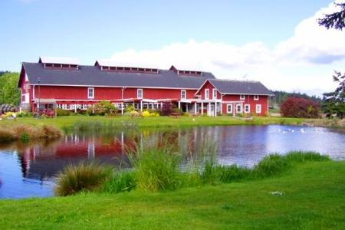
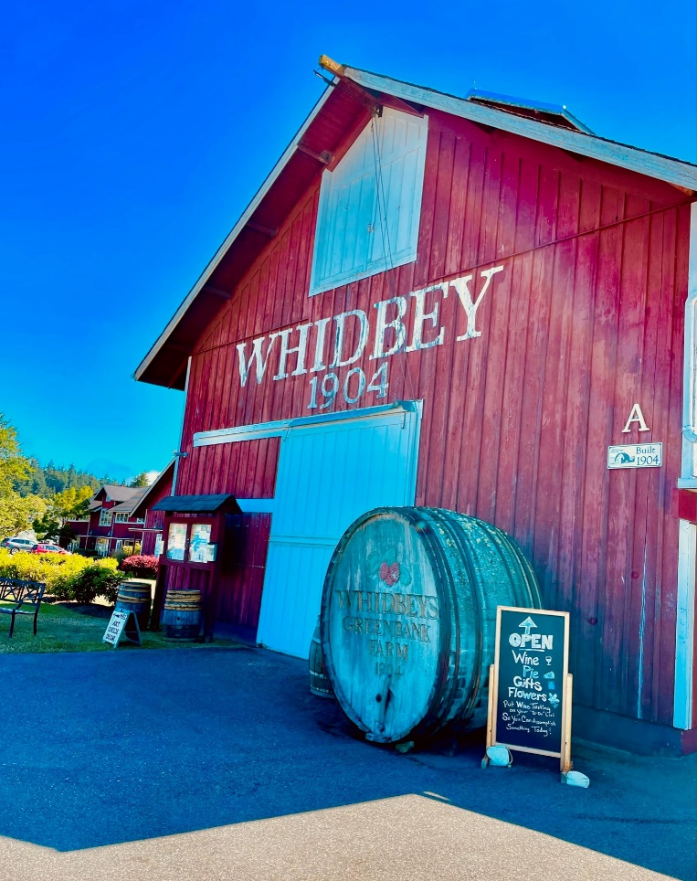Front of Barn

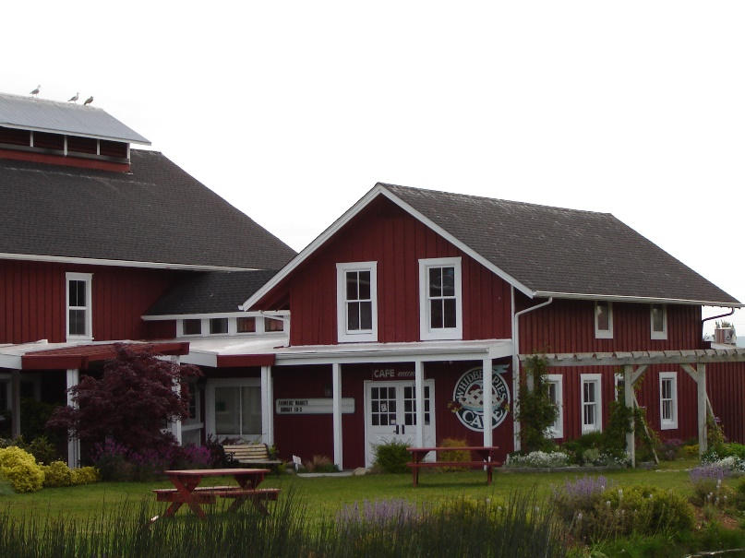Wine Shop and Bistro
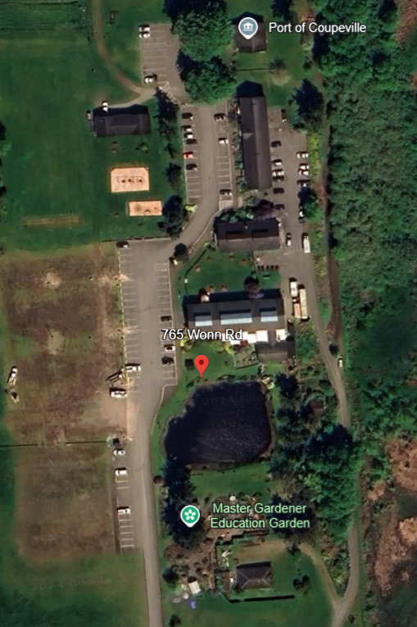
The main barn is called Barn A. The Wineshop is connected to the south of the barn perpendicular. The Bistro is connected to the Wine shop.

The Project
Barn A, the Wine shop, and the Bistro need new rooves installed. The cupulas on Barn A do not need to be done. There is a flat roof behind the bistro needs to be reroofed as well. The front flat roofs over the walkways are not included in this project.
The roof is gable shaped, L-shaped, 35 feet high. The siding is board and batten.
Permits will be acquired by the Port of Coupeville.
The scope of the work is as follows:
1. Tear off and dispose of a single layer composition roof on Barn A and all composition buildings attached to Barn A (breezeway and Bistro) as well as flat roof behind the bistro. Recycling materials as able. (Cupolas are not part of the project)
2. Inspect for dry rot and repair if any is encountered. Rot repair will be done via change orders throughout the project.
3. Install base sheet, peel and stick base sheet. Certain Teed's STA smooth torch down, metal drip edge around perimeter and perimeter and any pipe jacks or flashing, and Certain Teed's granulated cap sheet torch down.
4. Install 30# felt vapor barrier, metal drip edge around entire perimeters, metal valleys, starter, maintenance safety, and ridge shingles.
5. Install Certain Teed’s Landmark TL (Triple Laminate) composition shingles.
6. The facia and gutters need to be replaced.

See Attachment A for Historic Barn Regulations from DAHP.
Attachment B for dimensions.

