Port of coupeville

Statement of Work

Project Summary
The Pond at the Greenbank Farm is the fire suppression for the historic barn, it needs to be dredged, regraded and additional infrastructure added.

Budget
$188,000.00

Schedule
- The work can be done during daylight hours.
- The grass area across from the pond may be used for contractor materials.
- The parking lot can not be blocked for any length of time.
- Businesses will remain open during construction

Project Location
Greenbank Farm, 765 Wonn Rd, Greenbank WA 98253
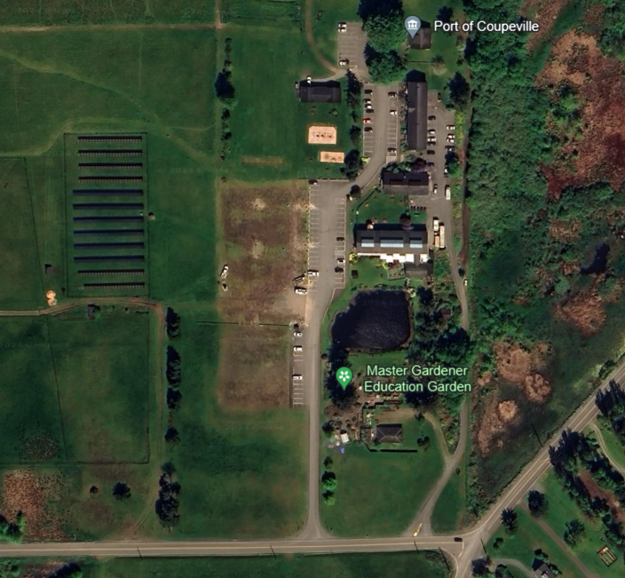

Goals, objectives & motivations
The goal is to ease maintenance of the pond/fire suppression unit to ensure safety of the surrounding structures. Allow the water to be used for agriculture irrigation. Reinforcements of the banks to ensure no erosion of the land surrounding the pond for safety of the infrastructure, and the visitors.

Unique Considerations
This is a man-made pond that was originally a creek from a natural spring. It leads to protected wetlands.

Future state/Detailed Requirements
This is a restoration and improvement project for the Greenbank Farms irrigation & fire pond under the management of Port of Coupeville. The goal is to regrade and dredge the pond while installing additional infrastructure to ease maintenance of the pond. The plans include (as a separate bid) for the installation of a large catch basin to isolate and ease removal of sediment as well as a bypass connection and valves to divert incoming stormwater.
The pond must be drained and bypassed, existing irrigation piping protected and construction runoff managed with BMPs during construction. Approximately 1195 CY of dredge and waste soil is expected to be hauled away and disposed of in accordance with local regulations. Dry hydrants will be replaced and installed per the site plan. To restore the pond quarry spalls and amended soil will be placed according to site plan. Jute matting and plantings will be used to stabilize pond slopes from erosion. After construction is complete, the pond will be refilled and resume function.
More detailed project information is included in Exhibit A.

Additional Information
Port of Coupeville Offices on site.
Mary Hogan is the project manager for the Port of Coupeville. Chris Michalopoulos is the Executive Director for the Port of Coupeville
Engineering plans Exhibit A.

Design or Consultant Information
Impact Design, LLC: Scott Goodall, MS, PE
5426 Barrett Road, Suite A103
Ferndale, WA 98248
(360) 389-8138

