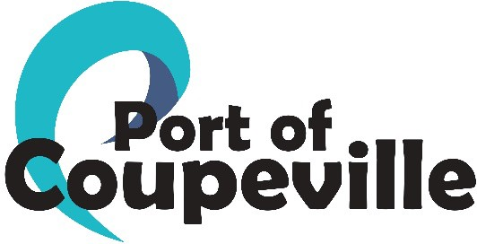 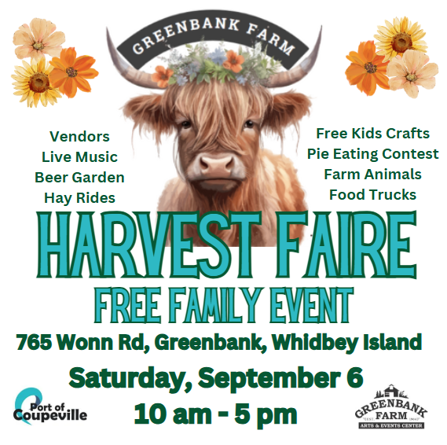 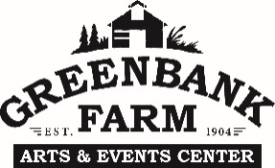

APPLICATION FORM

Name:

Vendor/Organization:

Phone: Email:

Address: City: State:

Type of Organization:  Vendor ($75)  Food Truck ($75)  Non-Profit Education Only No Sales (free)  Non-Profit Sales ($37.50)

Vendor Description:

Dates of rental space(s): September 6, 2025

Check enclosed, payable to The Port of Coupeville, P.O. Box 128, Greenbank, WA 98253. Vendors must comply with Island County, local and state regulations regarding the sale of vendor items or merchandise.

HOLD HARMLESS CONTRACT

(name of vendor/business) and their employees and/or volunteers shall defend, indemnify, and hold harmless the Port of Coupeville and the Greenbank Farm, including their officers, employees and agents from and against all liability, loss, expense, including reasonable attorney’s fees, or claims for injury or damages arising out of/or in connection with Greenbank Farm’s Vendor Market at Greenbank Farm, Greenbank, Washington.

Signature: Printed Name:

Title-Business: Submitted Date:

Approved: Date:

(doc: Outdoor Market Vendor Application 2025)